Here’s an overview of what we’ve got to do, then what follows is my breakdown of the work. This seems inherently “waterfall,” (one task is reliant on the next) so that drove things.
- Assignment says we must, “Follow the directions in the Project Report Template and complete sections 1, 2 and References/Appendix A.”
  - (Source: https://canvas.asu.edu/courses/254278/assignments/7225224?module_item_id=19177109 )
- From the rubric’s document, these are what those are:
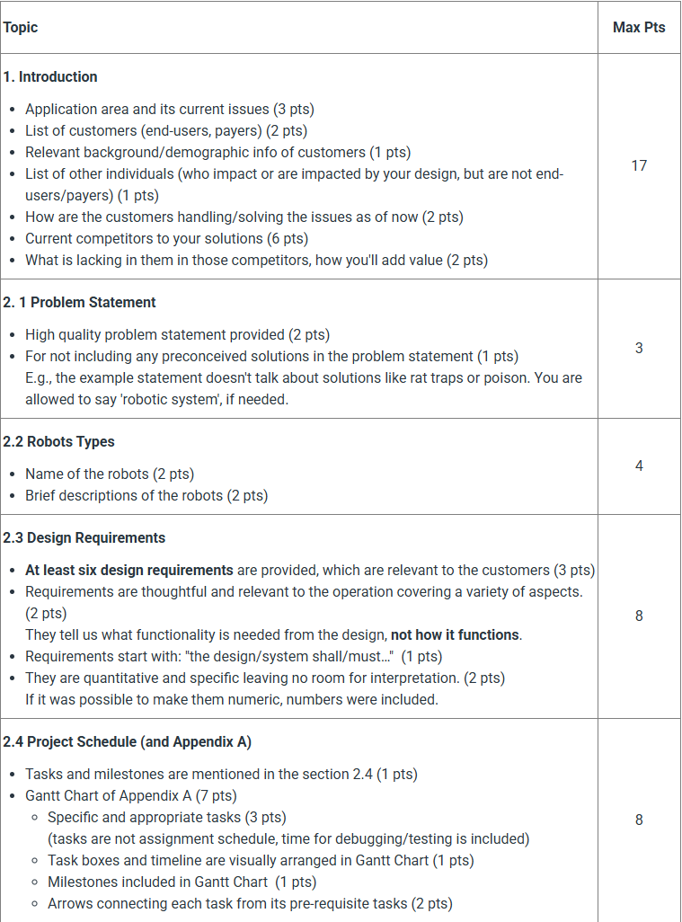
- Something to take a look at that would be helpful is this example document.
- From the Team Project Graphic Overview, here’s a description of each part and how I broke it down:
  - Problem Definition

During the first phase of the project, your team will collectively brainstorm ideas to identify the potential application area of a robot swarm system and the issues that users/customers face in that area. Otherwise, your team can select one of the default project options provided.

Everyone does this so we have multiple options to choose from.

Position: IDEA GENERATION (all of us)
Due Tuesday by 6pm. Everyone votes by 9pm.

Next, as a team, you'll conduct online research to identify (and perhaps talk to) potential customers to better understand their needs. You'll research existing options which may compete with your design. You’ll identify how your team’s design idea is unique and adds value. You’ll start to build a list of references to include in your Final Project Report.

Based on the results of your research, your team will agree on and write a formal problem definition. This is the problem that your project should seek to resolve.

Position: RESEARCH
Due Wednesday, 6pm.

Based on your problem definition, your team will formulate an idea for a specific robot swarm system that can achieve your objective. Each proposed swarm design must contain as many individual robots as there are team members and must contain a list of at least 6 design requirements. Each individual robot within the swarm should have a unique name and function and must be designed to cooperate with the other individual robots within your swarm.

Position: ROBOT REQUIREMENTS
Due Thursday noon.

Based on your robot swarm system idea, your team will identify the important tasks and milestones needed to complete your project. As a team, you will create a Gantt Chart to outline the project timeline.

Position: PLANNING/GANTT
Due Friday, Noon.

Position: FACILITATOR AND FINAL DOCUMENT (ME)
Due Friday by 10pm.

